REPORT FOR: | GOVERNANCE, AUDIT, RISK MANAGEMENT AND STANDARDS COMMITTEE
Date of Meeting: | 6 December 2017
Subject: | Treasury Management Strategy Statement and Annual Investment Strategy: Mid-year Review 2017-18
Key Decision: | No
Responsible Officer: | Dawn Calvert, Director of Finance
Exempt: | No
Decision subject to Call-in: | No
Wards affected: | All
Enclosures: | Appendix A – Economic and Interest Rates Update

Section 1 – Summary and Recommendations

Summary
This report sets out the mid-year review of treasury management activities for 2017-18.

Recommendation
GARMS Committee is requested to note the Treasury Management Mid-Year review for 2017-18.

Reasons
  - To promote effective financial management and comply with the Local
Authorities (Capital Finance and Accounting) Regulations 2003, other relevant guidance and the Council’s Financial Regulations.
- To keep Members informed of Treasury Management activities and performance.

Section 2 – Report

Introduction

- This report deals with treasury management activity which plays a significant part in supporting the delivery of all the Council’s corporate priorities.

Options considered

- The consideration of this report is a requirement of the CIPFA “Treasury Management in the Public Services: Code of Practice and Cross-Sectoral Guidance Notes (2011 Edition)” [The Treasury Management Code]

Background

- The Chartered Institute of Public Finance and Accountancy (CIPFA) defines Treasury Management as:
“The management of the local authority’s investments and cash flows, its banking, money market and capital market transactions; the effective control of the risks associated with those activities; and the pursuit of optimum performance consistent with those risks.”

The Council has adopted this definition.

- The Council is required to operate a balanced budget, which broadly means that cash raised during the year will meet cash expenditure.

      - The first main function of the Treasury Management operation is to ensure that this cash flow is adequately planned, with cash being available when it is needed. In line with the Treasury Management Strategy Statement surplus monies are invested in low risk counterparties or instruments commensurate with the Council’s low risk appetite, providing adequate liquidity initially before considering investment return.

      - The second main function of the Treasury Management service is the funding of the Council’s capital programme. This programme provides a guide to the borrowing need of the Council, essentially the longer term cashflow planning, to ensure that the Council can meet its capital spending obligations. This management of longer term cash may involve arranging long or short term loans, or using longer term cash flow surpluses. On occasion, any debt previously drawn may be restructured to meet Council risk or cost objectives.

      - The Local Government Act 2003 and supporting regulations require the Council to ‘have regard to’ “The Prudential Code for Capital Finance in Local Authorities (2011 Edition)” [The Prudential Code] and the Treasury Management Code to set Treasury and Prudential Indicators for the next three years to ensure that the Council’s capital investment programme is affordable, prudent and sustainable.

      - The CIPFA Treasury Management Code has been adopted by the Council.

- The primary requirements of the Treasury Management Code are as follows:
- Creation and maintenance of a Treasury Management Policy Statement which sets out the policies and objectives of the Council’s treasury management activities.
- Creation and maintenance of Treasury Management Practices which set out the manner in which the Council will seek to achieve those policies and objectives.
- Receipt by the full Council or Cabinet of an annual Treasury Management Strategy Statement - including the Annual Investment Strategy and Minimum Revenue Provision Policy - for the year ahead, a Mid-year Review Report and an Annual Report (stewardship report) covering activities during the previous year.
- Delegation by the Council of responsibilities for implementing and monitoring treasury management policies and practices and for the execution and administration of treasury management decisions.
- Delegation by the Council of the role of scrutiny of Treasury Management strategy and policies to a specific named body. For this Council the delegated body is Governance, Audit, Risk Management and Standards Committee.
- The purpose of this report is specifically to meet one of the above requirements, namely the mid-year report of Treasury Management activities for financial year 2017/18. The report details progress during the year against the Strategy approved by Council on 16 February 2017.The report covers the following:
- Treasury position as at 30 September 2017 including investment portfolio and borrowing portfolio (paragraphs 11-23);
- Economic and interest rates update (paragraph 24 and Appendix A);
- Compliance with Prudential Indicators (paragraphs 25-34);
- Local HRA indicators (paragraphs 35-36)
- Additional investment opportunities (paragraphs 37-43)

Treasury Position as at 30 September 2017

- The Council’s borrowings and investment (cash balances) position as at 30 September 2017 is detailed below:

Table 1: Outstanding Investments and Borrowings

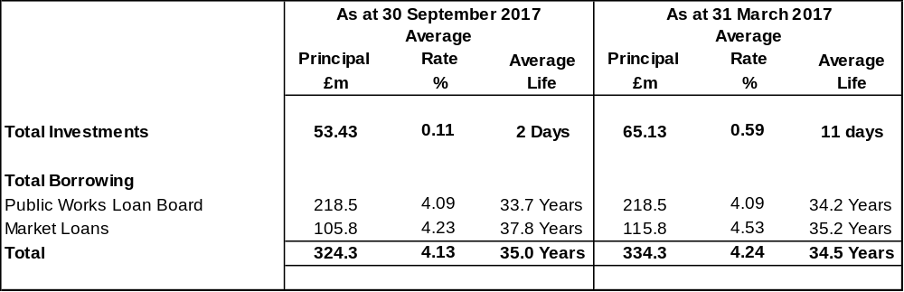

The above analysis assumes loans structured as Lender Option, Borrower Option loans (LOBOs) mature at the end of the contractual period. If the first date at which the lender can reset interest rates is used as the maturity date, the average life for market loans would be 14.4 years and, for the whole debt portfolio, 27.4 years. LOBOs are discussed further in paragraph 20.

Review of Investment Portfolio

- The Council remains a cautious investor placing security and liquidity considerations ahead of income generation. With Bank Rate at 30th September still at 0.25% it is impossible, at comparable risk levels, to invest at interest rates commonly seen in previous decades. During the first half of the year the rate on offer for instant access investments has been 0.01% (RBS), for investments of three months (Lloyds plc) 0.22% and for period of one year (Lloyds) 0.65%. Rates on investment returns have increased marginally since the increase in base rate to 0.50%.

With balances reducing and the demands of the capital programme it has not been appropriate to commit investments to periods beyond three months with a consequent effect on rates realised. Additionally, the maturity of some relatively high-earning investments has had the effect of reducing both the average interest rate being received and the average life of the investments

- The Council held £53.4m of investments as at 30 September 2017 compared with £65.1m at 31 March 2017. The investment portfolio yield for the first six months of the year is 0.11% against the average three months LIBOR of 0.30%. The reduction in investments is due primarily to the investments in the capital programme and the repayment of three loans maturing in June 2017. The Council’s investment income budget is £1.4m and the forecast outturn is an unfavourable balance of £1.3m due to the combination of the reduction in the cash balances and low yields.

- The only counterparties actively in use during the period have been Lloyds, Royal Bank of Scotland PLC and Svenska Handelsbanken.

- The performance of the investment portfolio is benchmarked on a quarterly basis by the Treasury Management Adviser both against their risk adjusted model and the returns from other local authorities. As at 30 September 2017, the average yield on the portfolio of 0.11%

- In addition to the investment of cash balances, the Council, at its meeting in July 2013, approved a loan of £15m to West London Waste Authority to help finance the cost of a new energy from waste plant. The term of the loan is 25 years at an interest rate of 7.604% on a reducing balance. The loan balance at the end of March 2017 is £16.4m which includes interest accrued to date. As the Waste Plant went live in December 2016 WLWA are now repaying the loan with Interest as agreed. There is a remaining facility of £0.25m from the original £15m loan that can be drawn down if required for any further work. For the financial year 2017/18, the outturn forecast on the interest accrued is £1.3m which is included as part of the investment income budget of £1.4m.

- The table below sets out the counterparty position as at 30 September 2017.

Table 2: Investment Balances

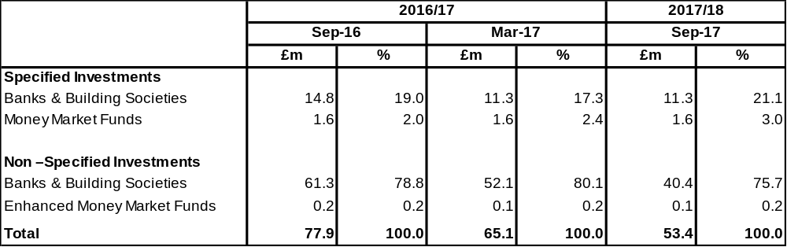

- At its meeting in November 2014 the Council approved HB Public Law Ltd. which is wholly owned by the Council to be added to the counterparty list. The Council has approved a start-up loan of £100,000 for three years. As at 30th September the balance outstanding is £21,145.29 which is due to be repaid in April 2018. The Council has approved a start-up loan of £274,000 for three years to Concilium Business Services limited which is wholly owned by the Council. As at the 30th September 2017 there have been drawdowns totalling £255,000.

Review of Borrowing Portfolio

- At 30 September 2017 the Council held £324.3m of external borrowing a reduction of £10m compared to 31 March 2017. This was due to the repayment of three loans maturing during June 2017. It is currently expected that borrowing of £M TBC will be required before the end of the financial year.

- Within this total is a sum of £50.8m borrowed during the period December 2007 to March 2010 under LOBO structures with maturities between 2060 and 2078. In exchange for an interest rate that was below that offered on long term debt by the PWLB, the lender has the option at the end of five years (and yearly or half yearly thereafter) to reset the interest rate. if the rate of interest changes, the Council is permitted to repay the loan at no additional cost. One of the loans arranged was with RBS in the sum of £20m at an interest rate of 3.50% with a maturity date of 2050. On 10 August 2017 RBS advised that they were forgoing their option to change the interest rate making this a fixed term loan until maturity. However they also then advised they were transferring the loan to a 3rd Party (Phoenix Life Assurance Ltd) for the remainder of the loan period. In future analysis of outstanding debt, including table 1 above and 3 below, this borrowing will be analysed as a fixed term loan at a fixed rate.

- The table below analyses the maturity profile of borrowing.

Table 3: Borrowing Maturity Profile

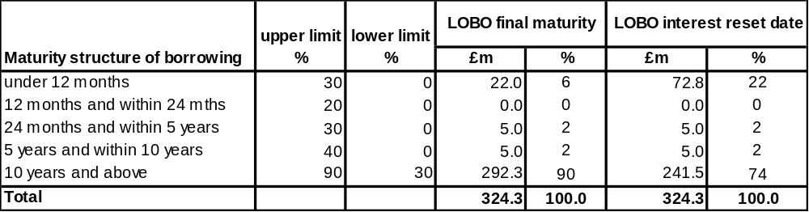

- The average borrowing rate is 4.2% and the forecast outturn on borrowing cost is £7.5m, below the budget of £8.1m. External borrowing will not be taken until the last quarter and temporary borrowing will be used if required.

- Debt rescheduling opportunities have been very limited in the current economic climate given the structure of interest rates and following the increase in the margin added to gilt yields which has impacted PWLB new borrowing rates since October 2010. A detailed review of the possibilities for rescheduling was discussed with the Treasury Management Adviser in July 2017 who advised that in a period of such low interest rates there are no financial advantages available which could be recommended for acceptance. No debt rescheduling was undertaken during the first six months of the year.

Economic and Interest Rates Updates

- An economic update for the first part of the 2017/18 financial year along with the interest rate forecast and commentary provided by Capita as at 30th September 2017 is included as Appendix A.

Compliance with Prudential Indicators

Capital Expenditure and Funding

- The Council’s capital expenditure programme is the key driver of Treasury Management activity. The output of the capital expenditure programme is reflected in the statutory prudential indicators, which are designed to assist Members’ overview and confirm the capital expenditure programme. The table below summarises the capital expenditure and funding for the current financial year and gives an indication of future levels of investment.

Table 4: Capital Expenditure

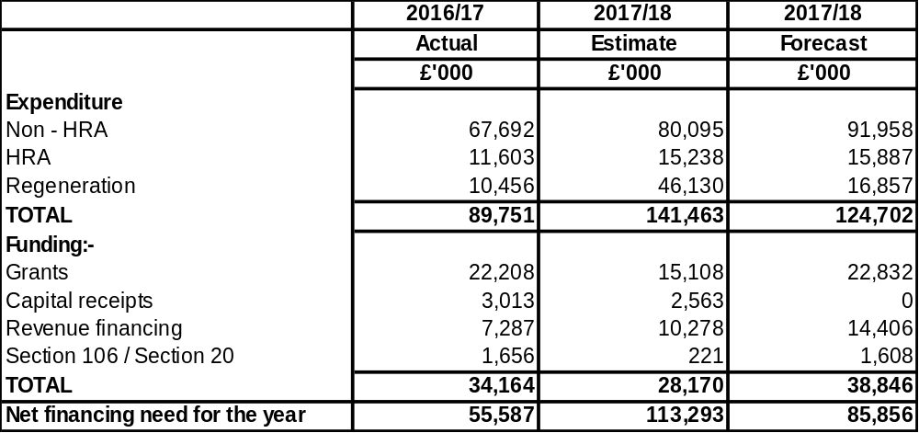

- The increase in the expenditure on the capital programme is due primarily to the carry forward of slippage from 2016/17. This has an impact on the annual change in capital financing requirement and net borrowing requirement as detailed in tables below. The revised forecast reflects the rephrasing of regeneration programme spend into future years.

Capital Financing Requirement (CFR)

- The CFR as set out in Table 5, is the total historic outstanding capital expenditure which has not yet been paid for from either revenue or capital resources. It is essentially a measure of the Council’s underlying borrowing need. Any new capital expenditure, which has not immediately been paid for, will increase the CFR.
Table 5: Capital Financing Requirement

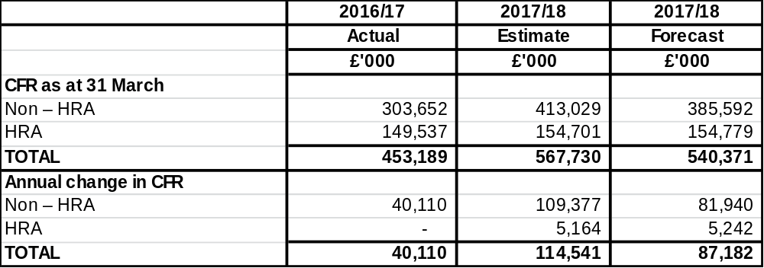

- Debt outstanding, including that arising from PFI and leasing schemes, should not normally exceed the CFR. As the Council has funded a substantial amount of capital expenditure from revenue resources, as shown in Table 6 below, current forecast gross debt of £349m is well below the CFR of £479m.

Table 6: Changes to Gross Debt

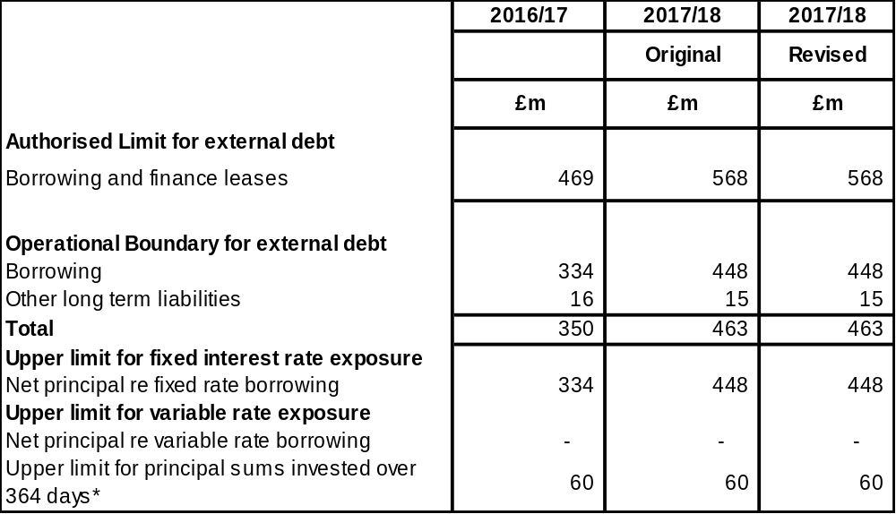

- The table below shows the net borrowing after investment balances are taken into account.

Table 7: Net Borrowing

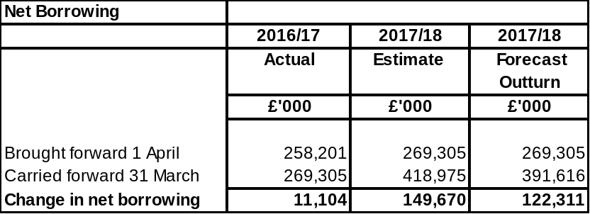

No external borrowing has been taken in the financial year to date by using internal borrowing; reducing cash balances. When cash balances fall below £30m, then temporary borrowing will be taken, to minimise borrowing costs, to be replaced by PWLB borrowing if longer term rates rise from the current low levels which are currently below 3%.

Operational Boundary and Authorised Limit

30. Operational Boundary – This limit is based on the Council’s programme for capital expenditure, capital financing requirement and cash flow requirements for the year.

31. Authorised Limit – This represents a limit beyond which external debt is prohibited. The Council’s policy is to set this rate at the Capital Financing Requirement. The Government retains an option to control either the total of all councils’ programmes, or those of a specific council, although this power has not yet been exercised.

Table 8: Boundaries

Affordability Indicators

32. Ratio of Financing Costs to Net Revenue Streams – This indicator identifies the trend in the cost of capital (borrowing, depreciation, impairment and other long term obligation costs net of investment income) against the net revenue stream. Tables 9 and 10 on next page show the current position for the General Fund and HRA respectively.

Table 9: Ratio of Financing Costs to Net Revenue Stream – General Fund

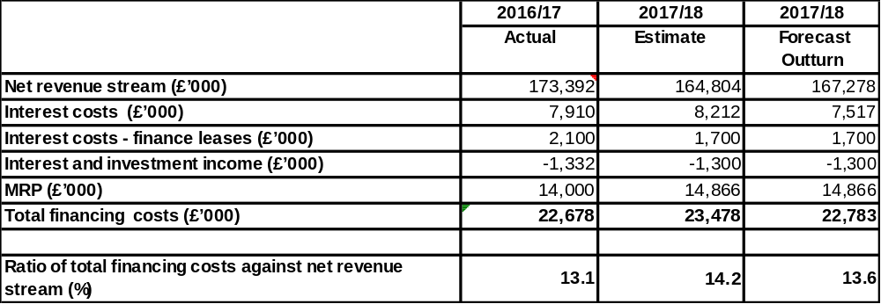

The ratio shows a small reduction between 2015/16 and 2016/17 which suggests that the capital programme remains affordable.

Table 10: Ratio of Financing Costs to Gross Revenue Stream HRA

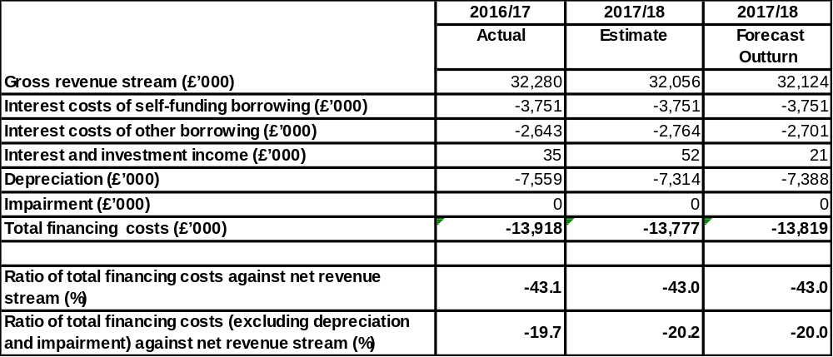

33. Incremental impact of Capital Investment Decisions on Council Tax and Housing Rents – This indicator identifies the revenue costs associated with proposed changes to the capital programme and the impact on Council Tax and Housing Rents.

34. The tables below identify the revenue costs associated with the proposed capital programme and the impact on Council Tax and housing rents.

Table 11: Incremental Impact of Capital Investment Decisions – Council Tax

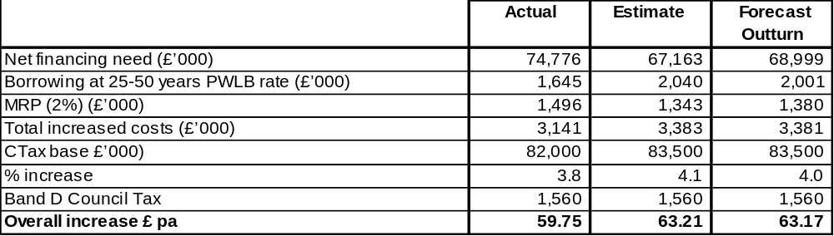

Table 12: Incremental Impact of Capital Investment Decisions – Housing Rents (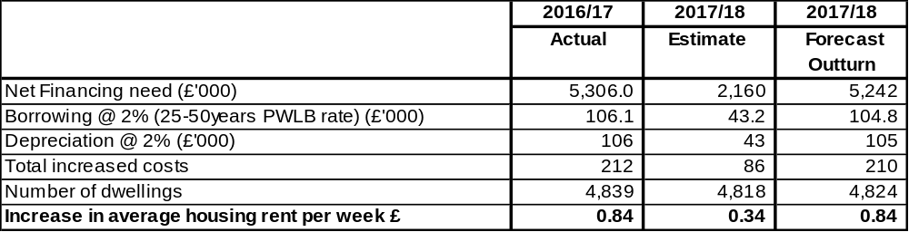

Local HRA indicators

35. The ratio of gross revenue stream to debt shows a consistent pattern which is affordable by the HRA. As the number of dwellings reduces over the two years, the debt outstanding per dwelling is estimated to increase. However, the annual increases are only marginal and the ratio compared to the average value of each dwelling is low enough for the measure to raise no concern.

Table 13: Local HRA Indicators

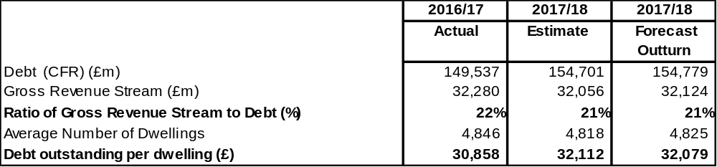

36. HRA Debt Limit is shown in the table below

Table 14: HRA Debt

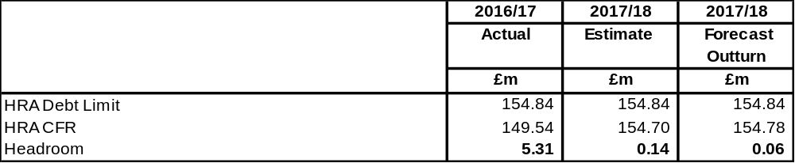

Additional investment opportunities

37. As discussed in paragraph 12 above interest rates available from institutions on the Council’s counterparty list and beyond are at historically very low levels and the Council is earning, overall, under 0.25% on its cash balances. Advice available to the Council suggests that returns are likely to remain low .

38. Notwithstanding this both officers and Members have expressed concern over the poor rates available and officers keep the counterparty list under review and opportunities to potentially realise better returns are investigated.

39. Regular meetings are held with the Treasury Management Adviser and they are always asked to update officers on investment opportunities which might be available. Vehicles discussed include gilts, European Investment Bank, money market funds, enhanced cash plus funds property funds and covered bonds. The Council has previously agreed to make direct investments of up to £20m in property but the other vehicles do not generally offer returns substantially in excess of those currently achieved.

Legal Implications

44. The purpose of this report is to comply with the Local Authorities (Capital Finance and Accounting) (England) Regulations 2003 and other relevant guidance referred to in the report.

Financial Implications

45. In addition to supporting the Council’s revenue and Capital programmes the Treasury Management net budget of £6.0m (Interest payable £7.3m; Interest receivable £1.3m) discussed in paragraphs 16 and 22 is an important part of the General Fund budget. Any savings achieved, or overspends incurred have a direct impact on the delivery of the budget.

Risk Management Implications

46. The identification, monitoring and control of risk are central to the achievement of the Treasury Management objectives. Potential risks are included in the directorate risk register and are identified, mitigated and monitored in accordance with Treasury Management Practice notes approved by the Treasury Management Group.

Equalities Implications

47. There are no equalities implications arising from this report.

Corporate Priorities

- This report deals with the Treasury Management activity which plays a significant part in supporting the delivery of all the Council’s corporate priorities.

Section 3 - Statutory Officer Clearance

Name: Dawn Calvert |  |  | Chief Financial Officer
Date: 24 November 2017
 |  |  | on behalf of the
Name: Caroline Eccles |  |  | Monitoring Officer
Date: 9 November 2017

Ward Councillors notified: | NO as report impacts on all Wards  .
EqIA carried out:  EqIA cleared by: | NO  There are no equalities implications arising from this “information” report.

Section 4 - Contact Details and Background Papers

Contact: Iain Millar (Treasury and Pensions Manager)
Tel: 020-8424-1432 / Email: iain.millar@harrow.gov.uk

Background Papers: None

Appendix A
Provided by Capita Asset Services at 30 September 2017
Economics and interest rates
Economics update

UK. After the UK economy surprised on the upside with strong growth in 2016, growth in 2017 has been disappointingly weak; quarter 1 came in at only +0.3% (+1.7% y/y) and quarter 2 was +0.3% (+1.5% y/y) which meant that growth in the first half of 2017 was the slowest for the first half of any year since 2012. . The main reason for this has been the sharp increase in inflation, caused by the devaluation of sterling after the referendum, feeding increases in the cost of imports into the economy. This has caused, in turn, a reduction in consumer disposable income and spending power and so the services sector of the economy, accounting for around 75% of GDP, has seen weak growth as consumers cut back on their expenditure. However, more recently there have been encouraging statistics from the manufacturing sector which is seeing strong growth, particularly as a result of increased demand for exports. It has helped that growth in the EU, our main trading partner, has improved significantly over the last year. However, this sector only accounts for around 11% of GDP so expansion in this sector will have a much more muted effect on the average total GDP growth figure for the UK economy as a whole.

The Monetary Policy Committee (MPC) meeting of 14 September 2017 surprised markets and forecasters by suddenly switching to a much more aggressive tone in terms of its words around warning that Bank Rate will need to rise. The Bank of England Inflation Reports during 2017 have clearly flagged up that they expected CPI inflation to peak at just under 3% in 2017, before falling back to near to its target rate of 2% in two years time. Inflation actually came in at 2.9% in August, (this data was released on 12 September), and so the Bank revised its forecast for the peak to over 3% at the 14 September meeting MPC. This marginal revision can hardly justify why the MPC became so aggressive with its wording; rather, the focus was on an emerging view that with unemployment falling to only 4.3%, the lowest level since 1975, and improvements in productivity being so weak, that the amount of spare capacity in the economy was significantly diminishing towards a point at which they now needed to take action. In addition, the MPC took a more tolerant view of low wage inflation as this now looks like a common factor in nearly all western economies as a result of increasing globalisation. This effectively means that the UK labour faces competition from overseas labour e.g. in outsourcing work to third world countries, and this therefore depresses the negotiating power of UK labour. However, the Bank was also concerned that the withdrawal of the UK from the EU would effectively lead to a decrease in such globalisation pressures in the UK, and so would be inflationary over the next few years.

It therefore looks very likely that the MPC will increase Bank Rate to 0.5% in November or, if not, in February 2018. The big question after that will be whether this will be a one off increase or the start of a slow, but regular, increase in Bank Rate. As at the start of October, short sterling rates are indicating that financial markets do not expect a second increase until May 2018 with a third increase in November 2019. However, some forecasters are flagging up that they expect growth to improve significantly in 2017 and into 2018, as the fall in inflation will bring to an end the negative impact on consumer spending power while a strong export performance will compensate for weak services sector growth. If this scenario were to materialise, then the MPC would have added reason to embark on a series of slow but gradual increases in Bank Rate during 2018. While there is so much uncertainty around the Brexit negotiations, consumer confidence, and business confidence to spend on investing, it is far too early to be confident about how the next two years will pan out.

EU. Economic growth in the EU, (the UK’s biggest trading partner), has been lack lustre for several years after the financial crisis despite the ECB eventually cutting its main rate to -0.4% and embarking on a massive programme of QE. However, growth picked up in 2016 and now looks to have gathered ongoing substantial strength and momentum thanks to this stimulus. GDP growth was 0.5% in quarter 1 (2.0% y/y) and 0.6% in quarter (2.3% y/y). However, despite providing massive monetary stimulus, the European Central Bank is still struggling to get inflation up to its 2% target and in August inflation was 1.5%. It is therefore unlikely to start on an upswing in rates until possibly 2019.

USA. Growth in the American economy has been volatile in 2015 and 2016. 2017 is following that path again with quarter 1 coming in at only 1.2% but quarter 2 rebounding to 3.1%, resulting in an overall annualised figure of 2.1% for the first half year. Unemployment in the US has also fallen to the lowest level for many years, reaching 4.4%, while wage inflation pressures, and inflationary pressures in general, have been building. The Fed has started on a gradual upswing in rates with three increases since December 2016; and there could be one more rate rise in 2017 which would then lift the central rate to 1.25 – 1.50%. There could then be another four more increases in 2018. At its June meeting, the Fed strongly hinted that it would soon begin to unwind its $4.5 trillion balance sheet holdings of bonds and mortgage backed securities by reducing its reinvestment of maturing holdings.

Chinese economic growth has been weakening over successive years, despite repeated rounds of central bank stimulus; medium term risks are increasing. Major progress still needs to be made to eliminate excess industrial capacity and the stock of unsold property, and to address the level of non-performing loans in the banking and credit systems.

Japan is struggling to stimulate consistent significant growth and to get inflation up to its target of 2%, despite huge monetary and fiscal stimulus. It is also making little progress on fundamental reform of the economy.

Interest rate forecasts

The Council’s treasury advisor, Capita Asset Services, has provided the following forecast:

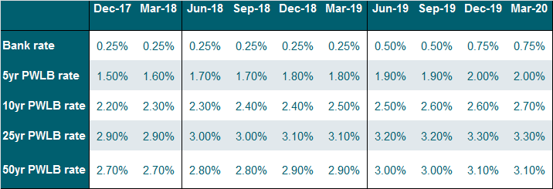

Capita Asset Services undertook its last review of interest rate forecasts on 9 August after the quarterly Bank of England Inflation Report. There was no change in MPC policy at that meeting. However, the MPC meeting of 14 September revealed a sharp change in sentiment whereby a majority of MPC members said they would be voting for an increase in Bank Rate “over the coming months”. It is therefore possible that there will be an increase to 0.5% at the November MPC meeting. If that happens, the question will then be as to whether the MPC will stop at just withdrawing the emergency Bank Rate cut of 0.25% in August 2016, after the result of the EU withdrawal referendum, or whether they will embark on a series of further increases in Bank Rate during 2018.

The overall balance of risks to economic recovery in the UK is currently to the downside but huge variables over the coming few years include just what final form Brexit will take, when finally agreed with the EU, and when.

Downside risks to current forecasts for UK gilt yields and PWLB rates currently include:

• UK economic growth and increases in inflation are weaker than we currently anticipate.
• Weak growth or recession in the UK’s main trading partners - the EU and US.
• Geopolitical risks in Europe, the Middle East and Asia, which could lead to increasing safe haven flows.
• A resurgence of the Eurozone sovereign debt crisis.
• Weak capitalisation of some European banks.
• Monetary policy action failing to stimulate sustainable growth and to get inflation up consistently to around monetary policy target levels.

The potential for upside risks to current forecasts for UK gilt yields and PWLB rates, especially for longer term PWLB rates include: -

• The pace and timing of increases in the Fed. Funds Rate causing a fundamental reassessment by investors of the relative risks of holding bonds as opposed to equities and leading to a major flight from bonds to equities.
• UK inflation returning to significantly higher levels causing an increase in the inflation premium inherent to gilt yields.

